

uk sales analysis

PROJECT - 2



January 26, 2025

MADE BY: - KRISH VISHNOI

***ENTITIES & FEATURES OF ANALYSIS***

1. *DESCRIPTION: -*
   1. Count (to know the highest entries products)
   2. Quantity (demand)
   3. Amount (highest amount giving products)
   4. Unit price, Amount & Quantity (profit & unit prices to sell)
2. *DATE: -*
   1. Year wise sales
3. *CUSTOMER_ID :-* 
   1. Amount (to know best purchaser by money)
   2. Quantity (to know total supplies)
4. *COUNTRY: -* 
   1. Amount (individual country classification)
   2. Domestic vs foreign (on the basis on amount)
   3. Quantity (individual country classification)
   4. Domestic vs foreign (on the basis of quantity)

***DESCRIPTION***

1. *COUNT: -* This analysis is done to know the products having most number of entries in the data set provided by the company. So that it becomes clear what products should be undermined for maintaining the stocks for the same products.

*OUTPUT: -*

* + - * 1. **White hanging heart T-light holder**
        2. **Regency cake stand 3-Tier**
        3. **Jumbo bag red retrospot.**

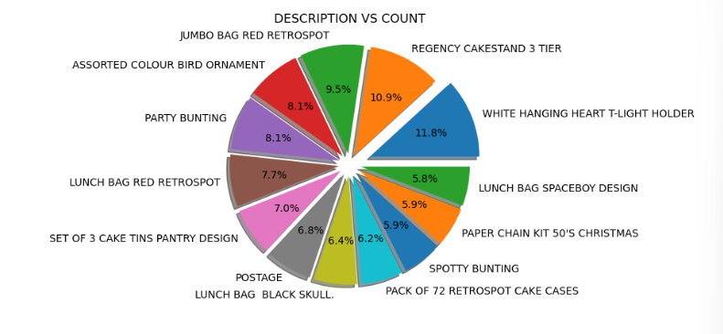

1. *QUANTITY: -* This analysis was done to know the products having highest number of purchased quantity in total. This will help to know the most liked & purchased products of the customer in the data set.

*OUTPUT: -*

* + - * 1. **World war 2 gliders asst design (53215)**
        2. **Jumbo bad red retrospot (45066)**
        3. **Assorted color bird ornament (35314)**

**THE WHITE HANGING HEART T-LIGHT HOLDER SEEMS TO BE THE HIGHEST IN TERMS OF ENTRIES WHILE IS NOT IN THE TOP 3 FOR THE HIGHEST SOLD PRODUCT BASED ON THE QUANTITY.**

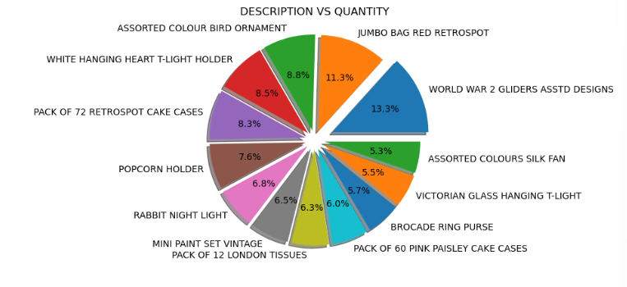

1. *AMOUNT: -* This analysis is done to know the product giving maximum price of purchases. This helps to target the products for good amount and stock management.

*OUTPUT: -*

* + - * 1. **Regency cake stand 3-tier**
        2. **White hanging heart T-light holder**
        3. **Jumbo bag red retrospot**

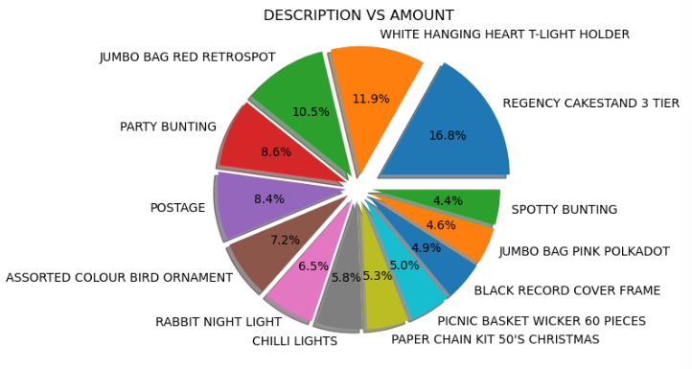

1. *AMOUNT, UNIT PRICE & QUANTITY: -* This analysis is done to decide the unit price of the top 10 products based on their behaviour when price is changed.

*OUTPUT: -*

* + - * 1. **Regency cake stand 3-Tier (at 10.95 -> 8.5m$)**
        2. **Regency cake stand 3-tier (at 12.75 -> 4.5 m$)**
        3. **White hanging heart T-light holder (at 2.55 -> 4.4 m$)**
        4. **Assorted color bird ornament (at 1.69 -> 3.7 m$)**

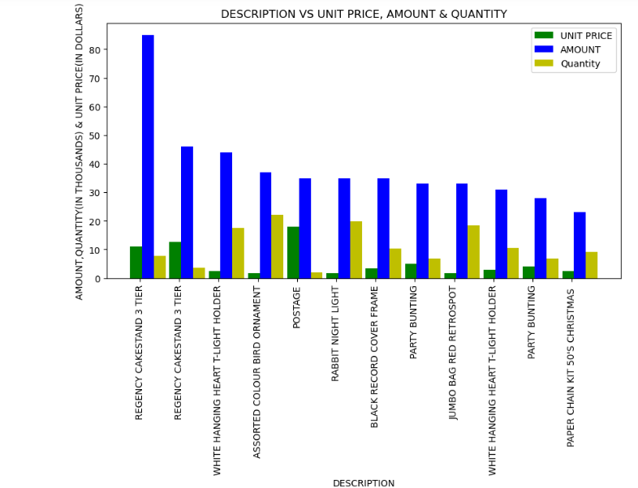

*FINAL OUTPUT: -*

* + - * 1. **Stocks should be undertaken with high sincerity for mentioned products in count analysis and** **quantity analysis section.**
        2. **The products in amount analysis section should be undertaken for stocks because of high profit and sales there.**
        3. **The last analysis section helps to decide the unit price of each product having highest sales (TOP 10). As the regency cake stand 3-tier face a massive decrease in sales when sold at 12.75 per unit instead of 10.95. there are chances and possibilities of a slight price increase in the products having unit price around 1, 2 & 3 $ to increase profits.**

***DATE***

1. *AMOUNT: -* This analysis is done to know the difference in the sales of the years (2010,2011) mentioned in the data set. Although it went clear after the analysis that the data set only have 1 month sales record of the year 2010, hence it is not legit to compare it with the data of the year 2011.

*OUTPUT: -* **The output of the analysis was that there is a huge difference in the sales where 2011 sales were near to 8 million $ while the month sales of 2010 were near to 560k $.**

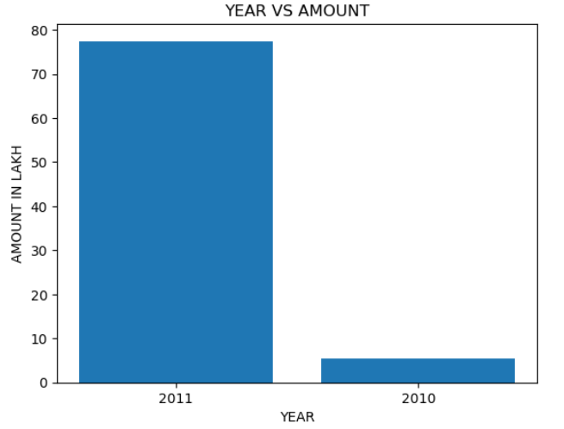

***CUSTOMER ID***

* 1. *AMOUNT: -* This analysis helped to know about the highest purchasing customers ( in terms of money & transactions ) using their unique ‘customer_id’. This helps a lot to know the best customers of the business and to maintain the relationship in the same way.

*OUTPUT: -*

* + - * 1. **14646 -> NETHERLANDS -> 279k $**
        2. **18102 -> UK -> 256k $**
        3. **17450 -> UK -> 187k $**
        4. **14911 -> EIRE -> 132k $**

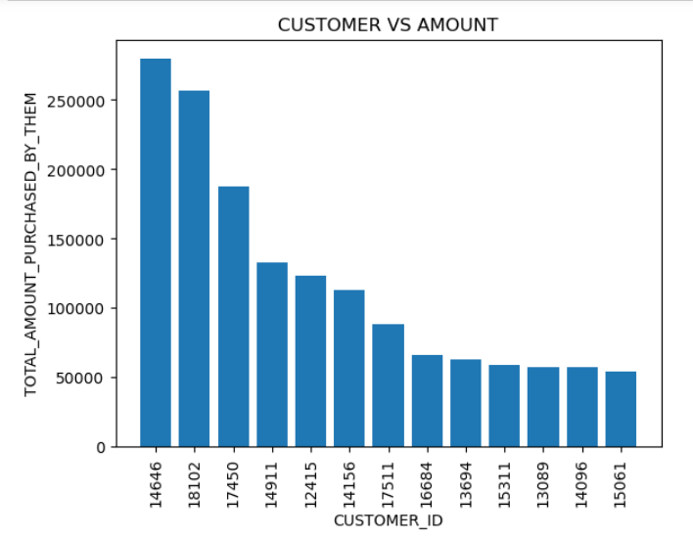

1. *QUANTITY: -* This analysis helps to about the customer to which highest number of products are supplied. This will help to monitor the favourite products of the customers and manage the inventory in the same way.

*OUTPUT: -*

* + - * 1. **14646 -> NETHERLANDS -> 196719**
        2. **12415 -> AUSTRALIA -> 77242**
        3. **14911 -> EIRE -> 77180**
        4. **17450 -> Uk -> 69029**

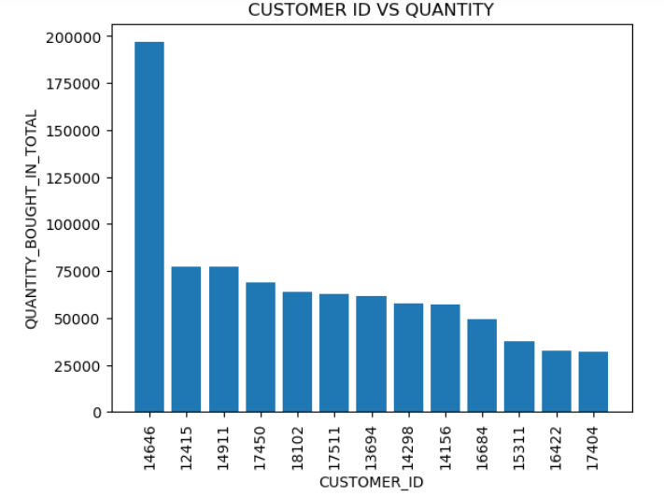

*FINAL OUTPUT: -*

* 1. **The customer with ID : 14646 seems to be the best purchaser in terms of amount and quantity both.**
  2. **The customer with ID : 17450 is also good in money purchases while lacks in quantity indicating that he must be buying the products having a higher unit price.**
  3. **Customer with ID : 12415 & 14911 can be targeted for a higher price in products for more profits.**

***COUNTRY***

1. *AMOUNT: -* This analysis is done the top 10 countries from which the highest money is coming. This will help to know the other countries that should be targeted.

*OUTPUT: -*

* + - * 1. **UK -> 6.7 million $**
        2. **NETHERLANDS -> 2.8 million $**
        3. **EIRE -> 2.5 million $**
        4. **GERMANY -> 2.2 million $**

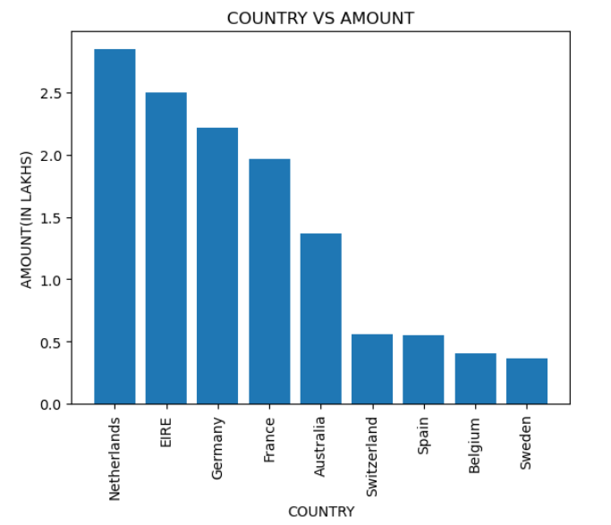

1. *DOMESTIC VS FOREIGN (AMOUNT): -* This analysis was done to compare the money from domestic vs foreign countries in the data set by comparing their total amount on a pie chart.

*OUTPUT: -*

* + - * 1. **DOMESTIC -> 91.8%**
        2. **FOREIGN COUNTRIES -> 8.2%**

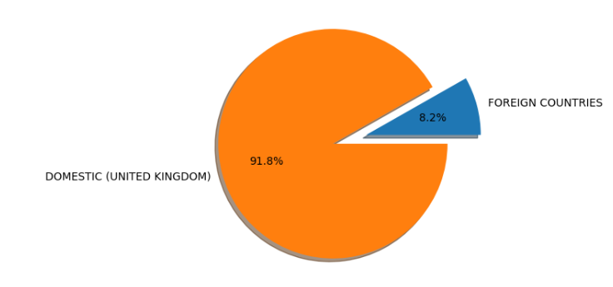

1. *QUANTITY:* - This analysis is done to the top 10 countries to which the highest total quantity of products are supplied. This will help to know the exports to other countries and cost management to do so to adjust that into the total amount to the customers.

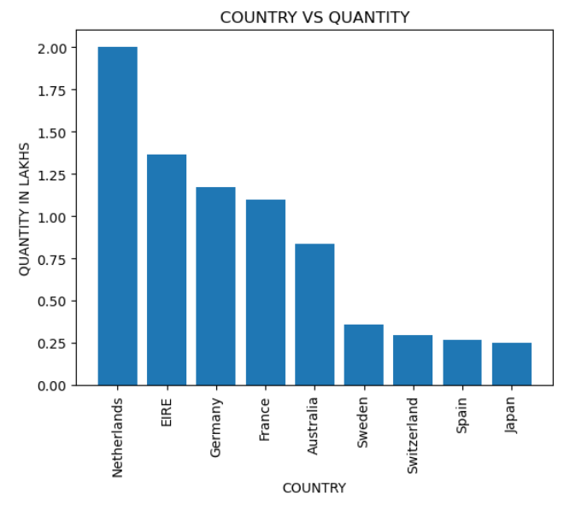

1. *DOMESTIC VS FOREIGN (QUANTITY): -* This analysis is done to compare the supplies to domestic vs foreign countries on the pie chart.

*OUTPUT: -*

* + - * 1. **DOMESTIC -> 81.7%**
        2. **FOREIGN COUNTRIES -> 18.3%**

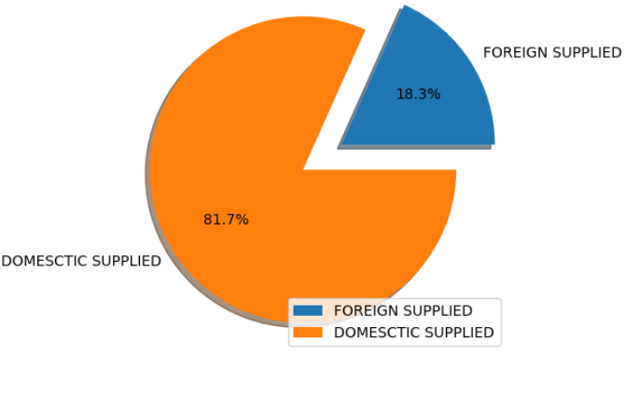

***CONCLUSIONS***

* Customers ( 14646, 17450,18102, 12415, 14911) from UK, NETHERLANDS, EIRE & AUSTRALIA are highly interested in buying below mentioned products: -
  + - WORLD WAR 2 GLIDERS ASSTD DESIGN.
    - JUMBO BAG RED RETRO SPOT.
    - ASSORTED COLOR BIRD ORNAMENT.
    - WHITE HANGING HEART T-LIGHT HOLDER.

Giving surplus amount of transaction and supplies.

* Any hike in the price of products having **UNIT PRICE** above 5$ is disliked, while there can be a slight increase in the prices of the products having **UNIT PRICE** around 1, 2 & 3 $.
* The business seems to be well settled in the domestic country (United Kingdom) but needs to be focused on the foreign country exports and business. This can be done making new customers having good impact in the society by fortune and by respect.